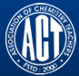 Association of Chemistry Teachers (ACT)
C/o. Homi Bhabha Center for Science Education (HBCSE), TIFR, Mumbai-400 088
News Letter Issue 2 / May – August, 2015
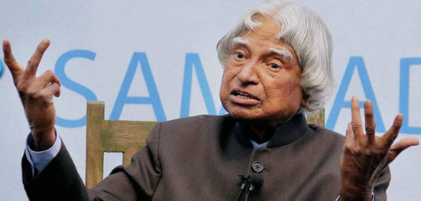
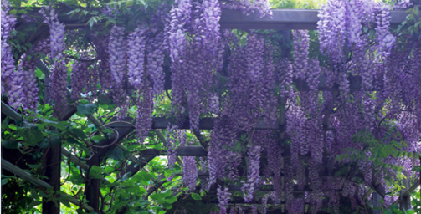
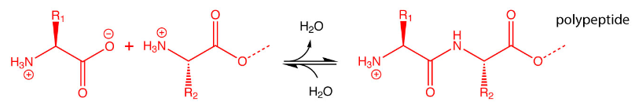
From Editor’s Desk

At the very outset, the entire fraternity of ACT pays respectful homage to our beloved previous Honorable President of India, Late Dr. APJ Abdul Kalam. To me personally it is great loss as we were colleagues at Vikram Sarabhai Space Centre, Thiruvananthapuram, Kerala, the Mother Centre of Indian Space Research Program; and who were a part of the team that initiated this centre’s activities way back in 1965. I had the privilege of long association of 15 years with him.
The editorial team’s work has fructified now and the first issue of ACT News Letter has gone on board the ACT – Website and this is a good encouragement to the entire Editorial Team. All the contents of each issue are sourced from different websites and the references are quoted so as to not to violate any copy right issues. The main objective of bringing out such new topics to the focus of the readers is to update them on latest trends in chemical and allied arenas of research so as to kindle new thinking in the minds of academicians and researchers that can result into development of new concepts, new green processes and products. We humbly request the entire fraternity of ACT to continue to contribute both in terms of their academic and individual achievements for the benefit of entire ACT Community. Wishing you and all your family members, colleagues, friends and relatives A VERY HAPPY, HEALTHY & PROSPEROUS DUSSEHRA

The Editorial Team

Interesting Molecular Structures
By Dan Gezelter
Everyone knows that Capsaicin is the hot stuff in chili peppers. Very few know that Chavicine is the hot stuff in black pepper. Chavicine slowly isomerizes into Piperine, which is less pungent.

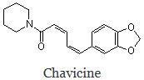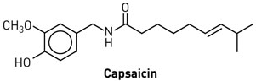
--------------------------------------------------------------------------------------------------------------------------
Tuesday, 11 February 2014 - 5:51pm IST | Agency: ANI
Now, turmeric powder drug to help beat breast cancer
According to a new study at the University of Louisville, curcumin, a spice used in the preparation of turmeric powder, reduced the size of tumors in mice by a third while slowing the reproduction rate of rogue cells, the Daily Express reported.
Researchers have now packed the anti-cancer properties of cur cumin in two millimeters long dissolving capsules that contain 200 milligrams of powder.
The findings also showed that ingesting capsules resulted in significant reduction in both the tumor multiplicity and tumor volume while consuming curcumin in a diet was ineffective.
--------------------------------------------------------------------------------------------------------------------------
This Common Spice May Help Boost Memory (Turmeric)
NDTV Cooks, Modified: January 12, 2015 12:36 IST
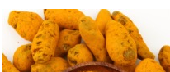 You would have never known that your spice cabinet secretly holds the best remedies for some of the most common ailments. Spices can not only turn around a boring meal but they can also heal your body naturally. Turmeric is one such spice that comes from the root of the Curcuma plant. Since ancient times, it has been used to heal wounds and cure stomach ailments.
The active compound curcumin found in turmeric is known to have various positive effects like anti-inflammatory, antioxidant, antibacterial, and antiviral activities.
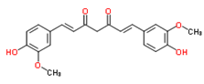
Mark Wahlqvist and his team carried out experiments in Taiwan that involved testing the working memory of men and women aged 60 or older who had recently been diagnosed with untreated pre-diabetes. "Working memory is widely thought to be one of the most important mental faculties, critical for cognitive abilities such as planning, problem solving and reasoning," he said. "Assessment of working memory is simple and convenient, but it is also very useful in the appraisal of cognition and in predicting future impairment and dementia," said Wahlqvist.
In the placebo-controlled study, subjects were given one gram of turmeric with an otherwise nutritionally bland breakfast of white bread. Their working memory was tested before and after the meal. Wahlqvist concludes, "We found that this modest addition to breakfast improved working memory over six hours in older people with pre-diabetes. Our findings with turmeric are consistent with these observations, so far as they appear to influence cognitive function where there is disordered energy metabolism and insulin resistance."
--------------------------------------------------------------------------------------------------------------------------

ACT Activities
• National Seminar on "Sustainable solutions to water, wastewater and solid waste" on May 8-9, 2015 at Centre for Fluorosis Research, A. N. College Patna in collaboration with CSIR-NEERI and UNESCO. Prof Subhash Prasad Singh served as the Organizing Secretary of the national seminar.
- Dr. M. R. R. Prasad delivered an invited talk at the 9th National Conference on Solid State Chemistry and Allied Areas, held during 08 – 10 May, 29015, organized by the Bhaskaracharya College of Applied Sciences, University of Delhi, Delhi.
- A workshop on "Chromatography and Spectroscopy" for college teachers and research scholars at SIES-Institute of Chromatography and Spectroscopy at Nerul, Navi Mumbai on June1-6 2015.
- Dr. M. R. R. Prasad gave an invited talk on June 09th, 2015, at the UGC-Human Resources Development Center, Dr. B. R. Ambedkar Marathwada Universty, Aurangabad, to the participants of STC on Curriculum & Research.
- Dr. M. R. R. Prasad gave an invited talk on June 10th, 2015, at the UGC-Academic Staff College, Dr. B. R. Ambedkar Marathwada Universty, Aurangabad, to the participants of Special Summer School Program.
- On 16th June, 2015, participants of Australian National Chemistry Quiz-2014 (ANCQ-14) were felicitated and awards presented in the Department of Chemistry, Kashmir University under the Chairmanship of Head, Dept. of Chemistry.
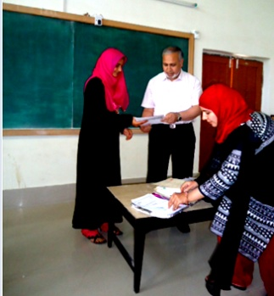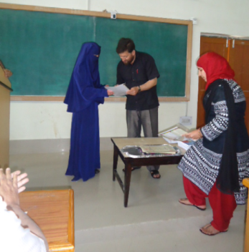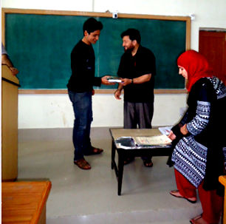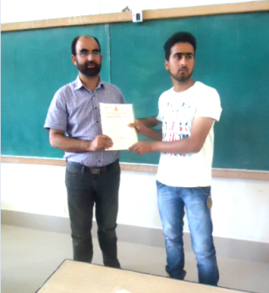
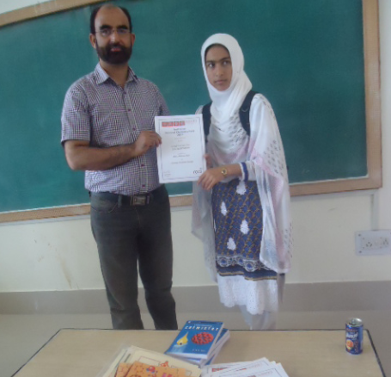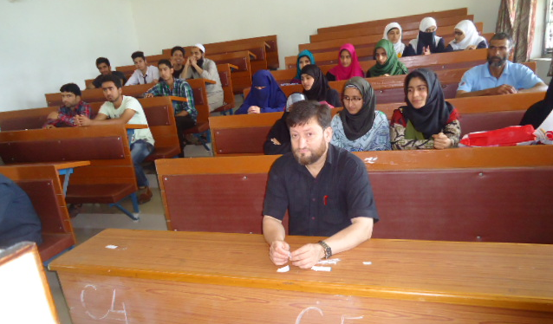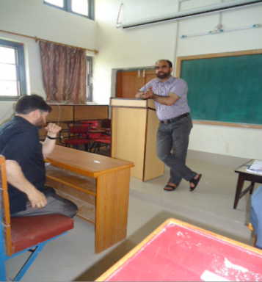

- Dr. M. R. R. Prasad gave an invited talk on June 30th, 2015, at the UGC-Human Resources Development Center, Dr. B. R. Ambedkar Marathwada Universty, Aurangabad, to the participants of 109th Orientation Program..
- Dr. Mannam Krishna Murthy, Co-opted Member, ACT-Southern Zone, presented a research paper entitled "Chemo selective hydrolysis of terminal isopropylidene acetals using PVP/Iodine as reusable catalyst" at 'Pharmacy and Pharmaceutical Science Conference 2015', organized by International medical University, Malaysia, during 1st and 2nd August 2015.
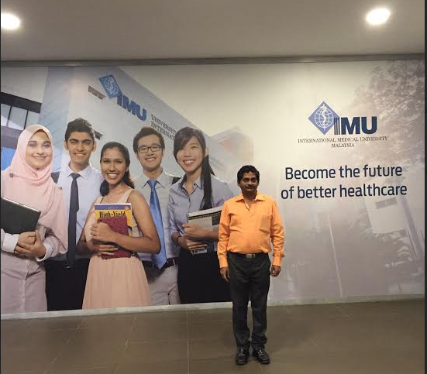

- National Conference on "Innovations in Chemical Sciences and Technology" ,NCICST 2015 on August 21, 2015 at Scott Christian College, Nagercoil, Kanyakumari ,Tamil Nadu
- Second National Conference on "New Renaissance in Chemical Research" on August 28-29, 2015 at SRM University, Ramapuram Campus, Chennai.

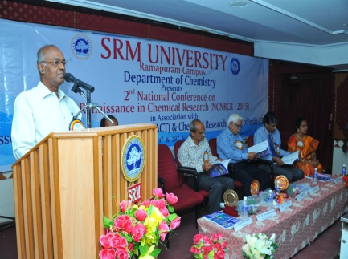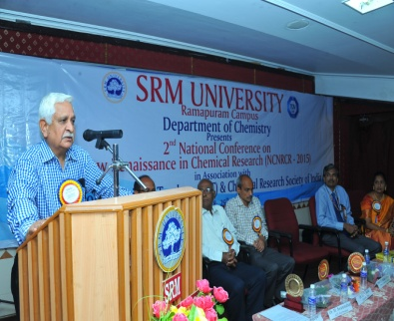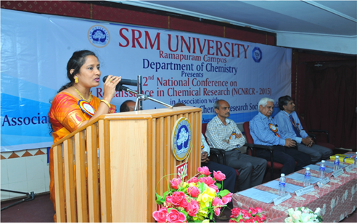
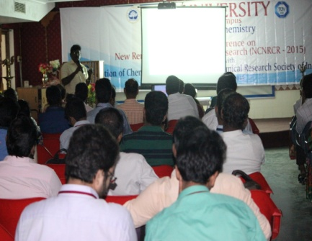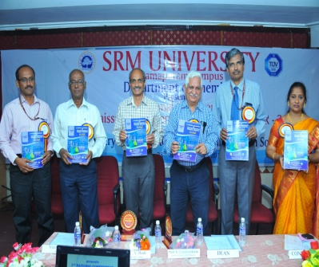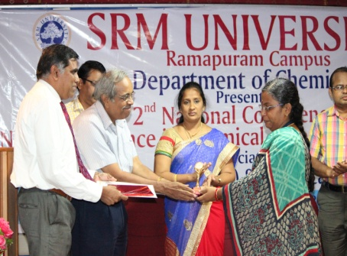

- Concept Test in Chemistry for undergraduate students was conducted all over the country on August 31 2015 under the dynamic leadership of Prof Subhash Prasad Singh, National Coordinator
- The Australian National Chemistry Quiz (ANCQ) conducted by The Royal Australian Chemical Institute, Australia, was held in the Department of Chemistry, University of Kashmir today on 3rd September, 2015. In this quiz 278 students of class 7th, 8th, 9th, 10th, 11th and 12th belonging to various Higher Secondary and High Schools of the Kashmir Valley, participated. The Quiz was also simultaneous conducted at SRM Welkin Higher Secondary School, Spore, where 188 students participated in this event.
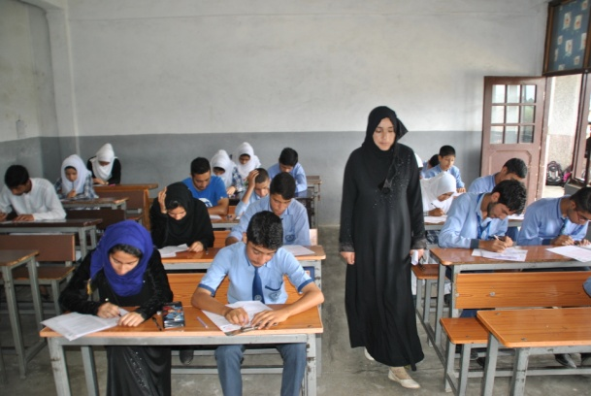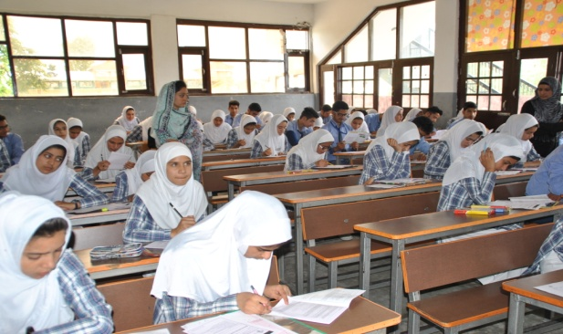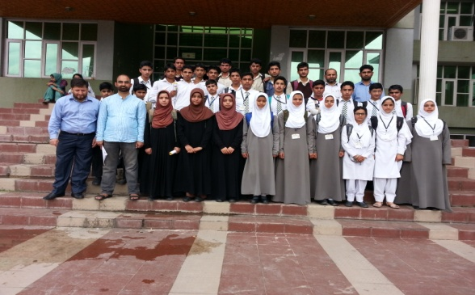

- Gave an invited talk entitled "Key role of chemistry in modern life" at UGC National seminar on 'Recent advances in chemistry', organized by K B N College (Autonomous), Vijayawada, during 18th and 19th September 2015.
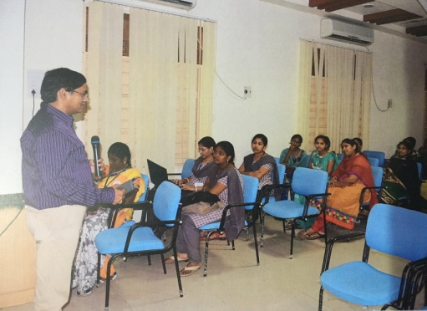

Forthcoming activities:
- National Seminar on "Nano materials and their applications" NSNA 2015 on October 1, 2015 at Department of Chemistry, Mar Ivanios College (autonomous) Nalanchira, Thiruvananthapuram, Kerala.
- National Convention of Chemistry Teachers (NCCT 2015) and National Symposium on "Innovative Methods in Chemistry Education" (IMCE 2015) will be held on October 8-10 2015 at Lucknow University, Lucknow under the able convenorship of Prof Sudha Jain, former President, ACT. ACT- ECM will be held on Oct 8 and ACT AGM will be held on Oct 9 2015 during NCCT 2015.
- National Standard Examination in Chemistry NSEC 2015 will be held in November 2015 at over 1000 centers all over the country. NSEC 2015 is being organized by ACT with active support from IAPT.
---------------------------------------------------------------------------------------------------------
Editorial Board
Dr. M. R. R. Prasad – Editor Dr. K. Sudhakarbabu
Dr. Subhash Prasad Singh Dr. PVS Machiraju
Dr. Altaf Pandit Dr. (Mrs.) Helen Kavitha
Prof. D. C. Deka

